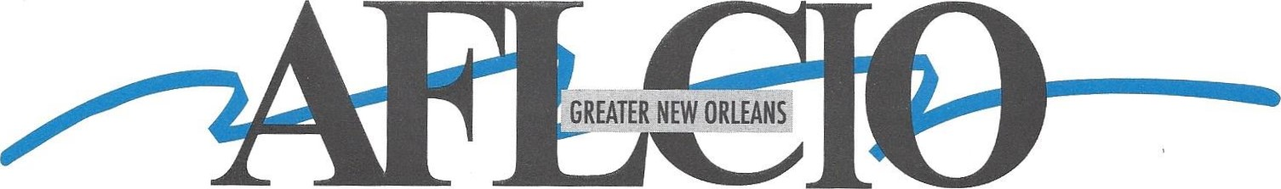

American Federation of Labor • Congress of Industrial Organizations

***AFL-CIO EXECUTIVE BOARD MEETING***

***Date: Thursday, May 22, 2025***

***Time: 6:00 PM***

***Location: IBEW Local Union #130***

***3200 Ridgelake Drive Suite 300***

***Metairie, LA 70002***

***Please make every effort to attend.***

***If you cannot attend,***

***please send a delegate in your place.***

***Thank You,***

***Tiger***

2540 Severn Avenue, suite 203 - Metairie, Louisiana 70002 - 504-482-0197 - Fax 504-482-6958

Robert "Tiger" Hammond, Ill — [tiger@gnoaflcio.com](mailto:tiger@gnoaflcio.com)

Serving Jefferson, Lafourche, Orleans, Plaquemines, St. Bernard, St. Charles, St. John the Baptist and Terrebonne Parishes Since 1901

Robert "Tiger" Hammond, Ill / President Dave Cash / Vice President Chip Fleetwood / Secretary-Treasurer @00046